Sensory Friendly
Pre-Visit Guide

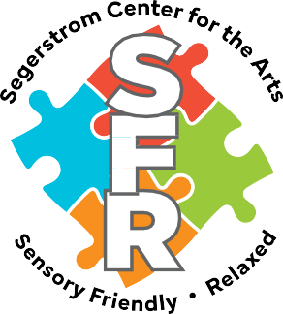

Theater

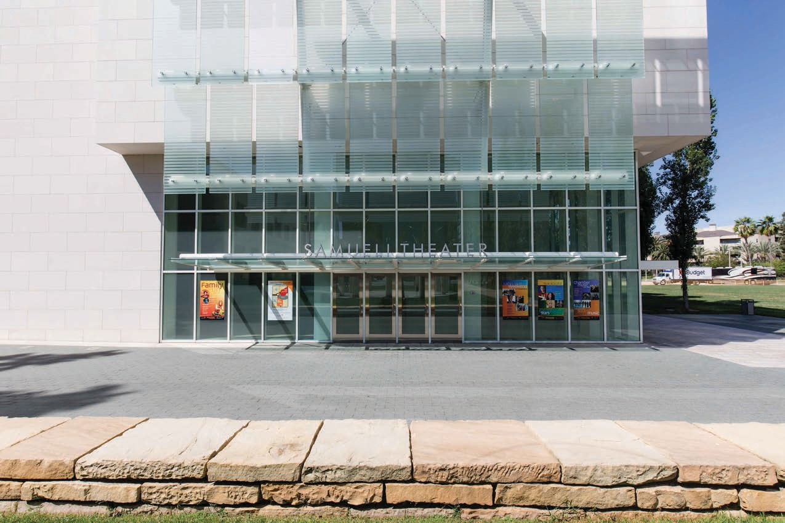I am going to a theater at the Segerstrom Center for the Arts to see a show. The theater is named Samueli Theater.

Park the car

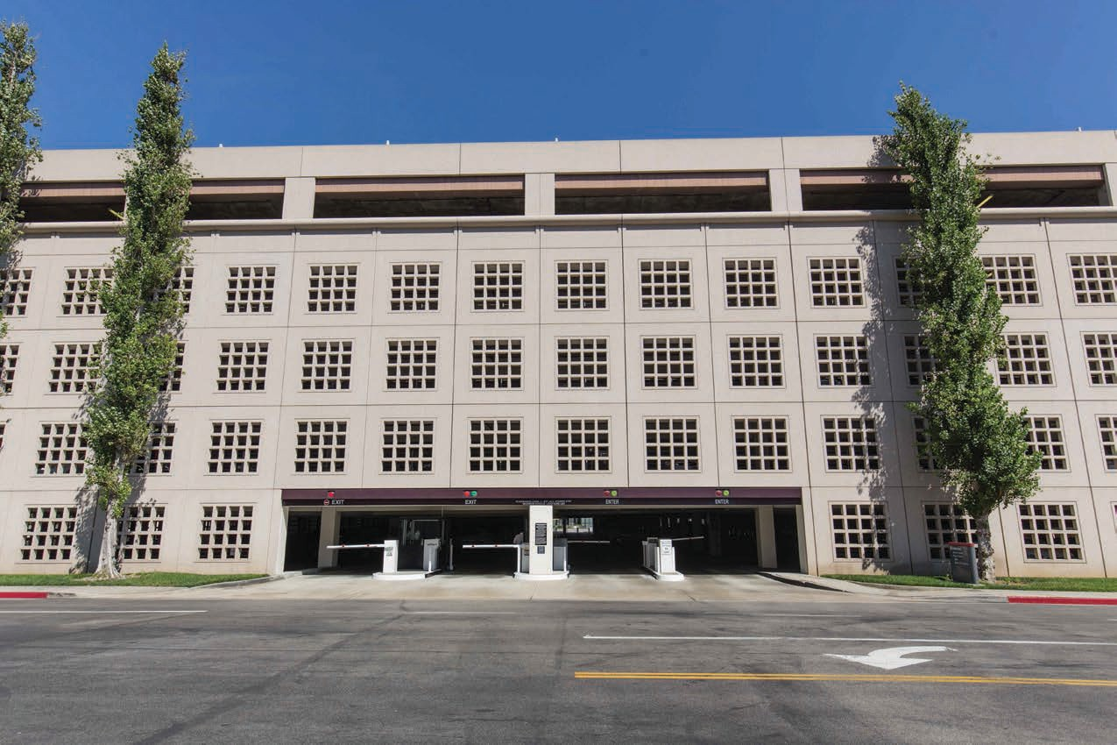We will park the car in the parking structure, then walk to the theater entrance.

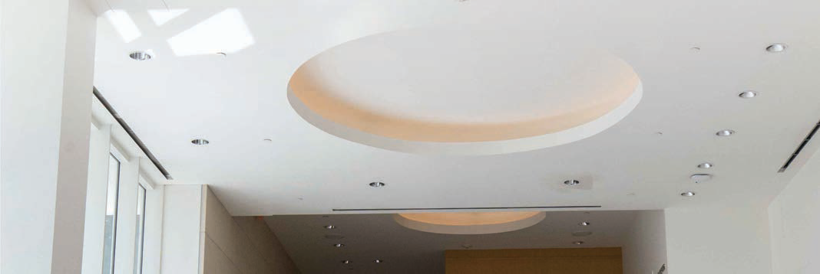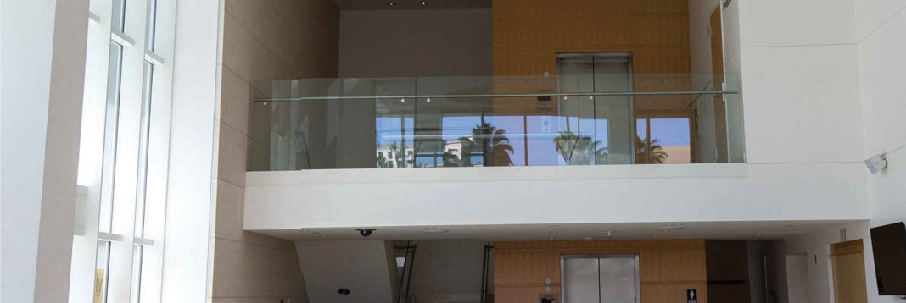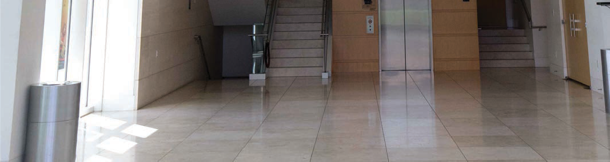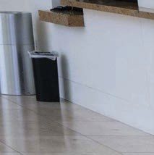Lobby

The Samueli theater lobby is white and has a tall ceiling.
It can be noisy in the lobby.
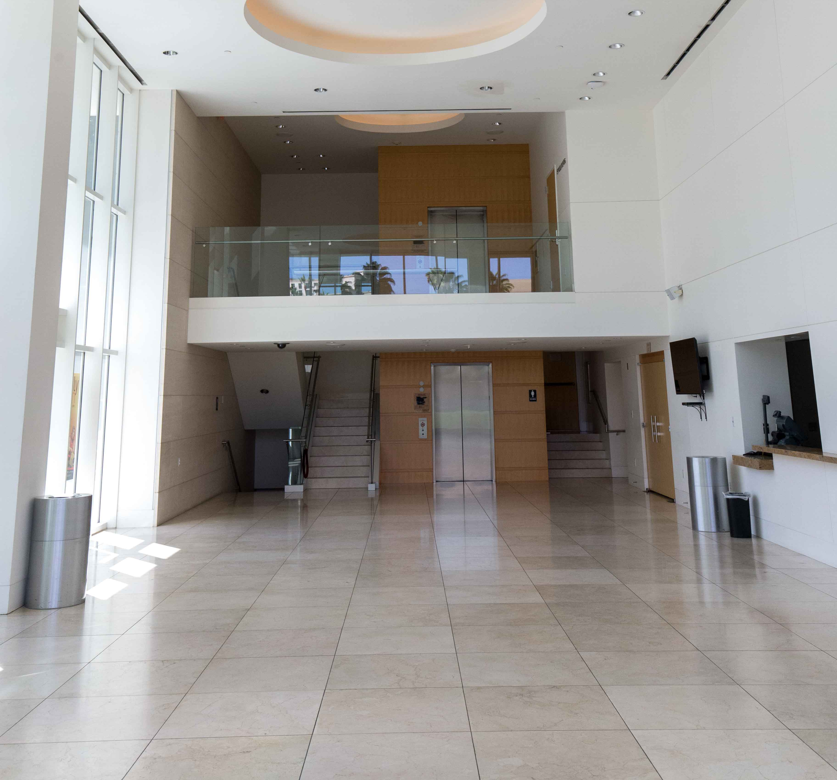
We will walk in the lobby to get to the theater where we will watch the show.

Box office

Before we go into the theater, we must get tickets for the show.
We will go to a place called the box office to get tickets.
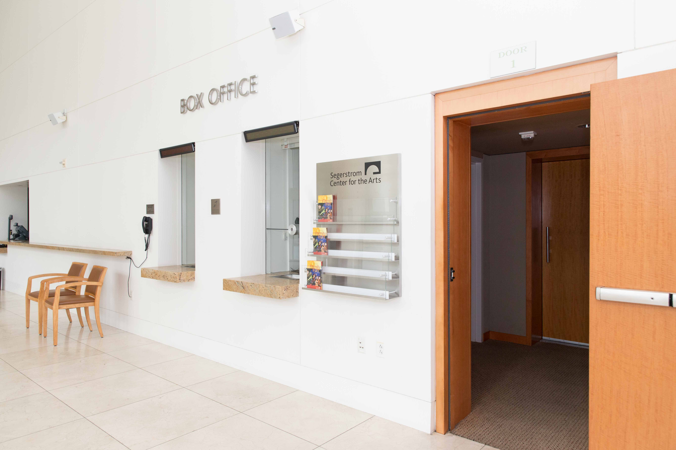
Every person must have a ticket to get into the theater.

Box office window

The box office has a small window with a person on the other side.

We will tell the person behind the window our name and the show we are going to.

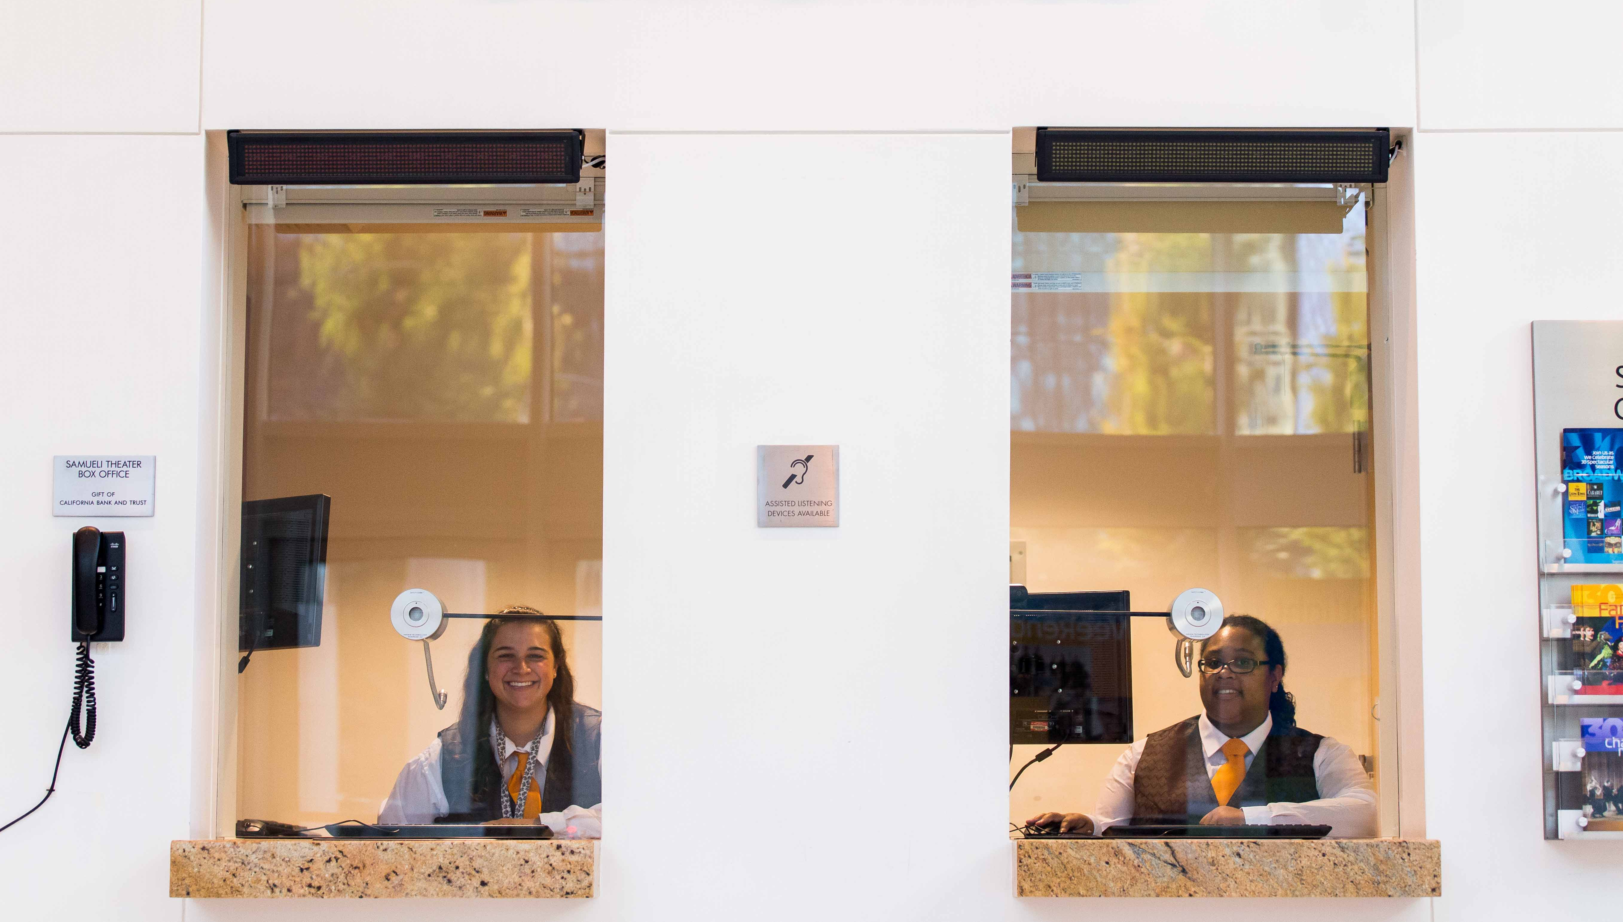
The person behind the window will give us tickets for the show.

Ticket machine

The theater usher will take the ticket to scan with a machine that beeps.

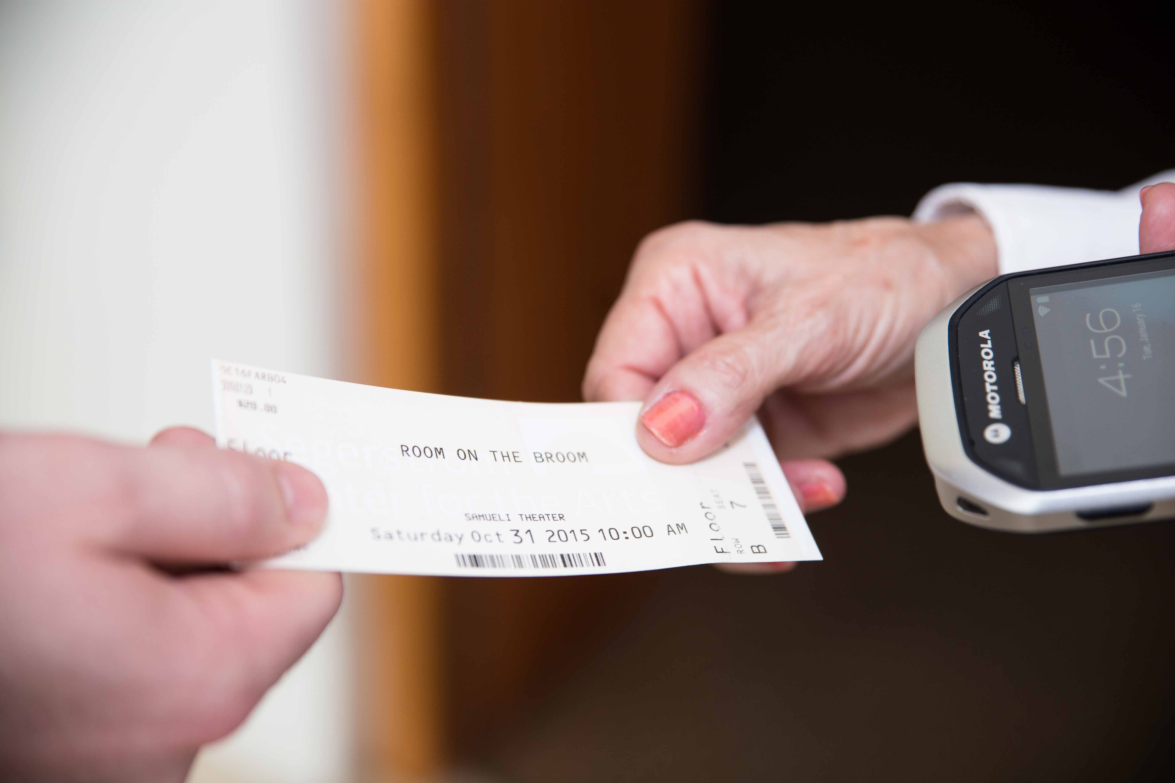
After the beeping sound, my family and I can go into the theater.

Theater usher

The theater usher is a friendly helper.
We can ask the theater usher for help.
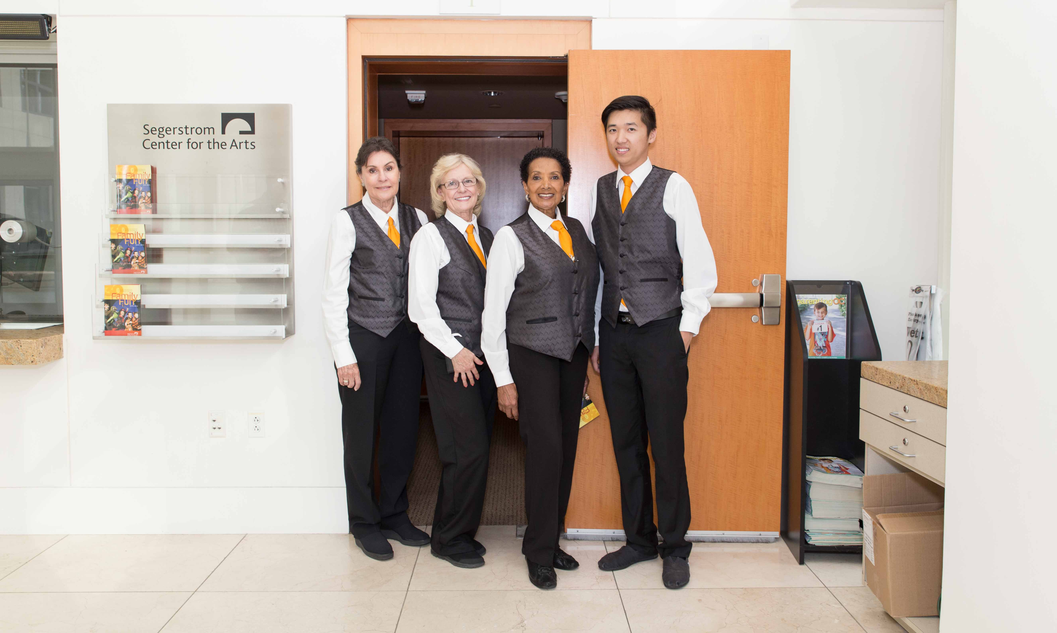
The theater usher can help me and my family find our seats.

Enter the Theater

When we hear the bell, we will enter the theater.

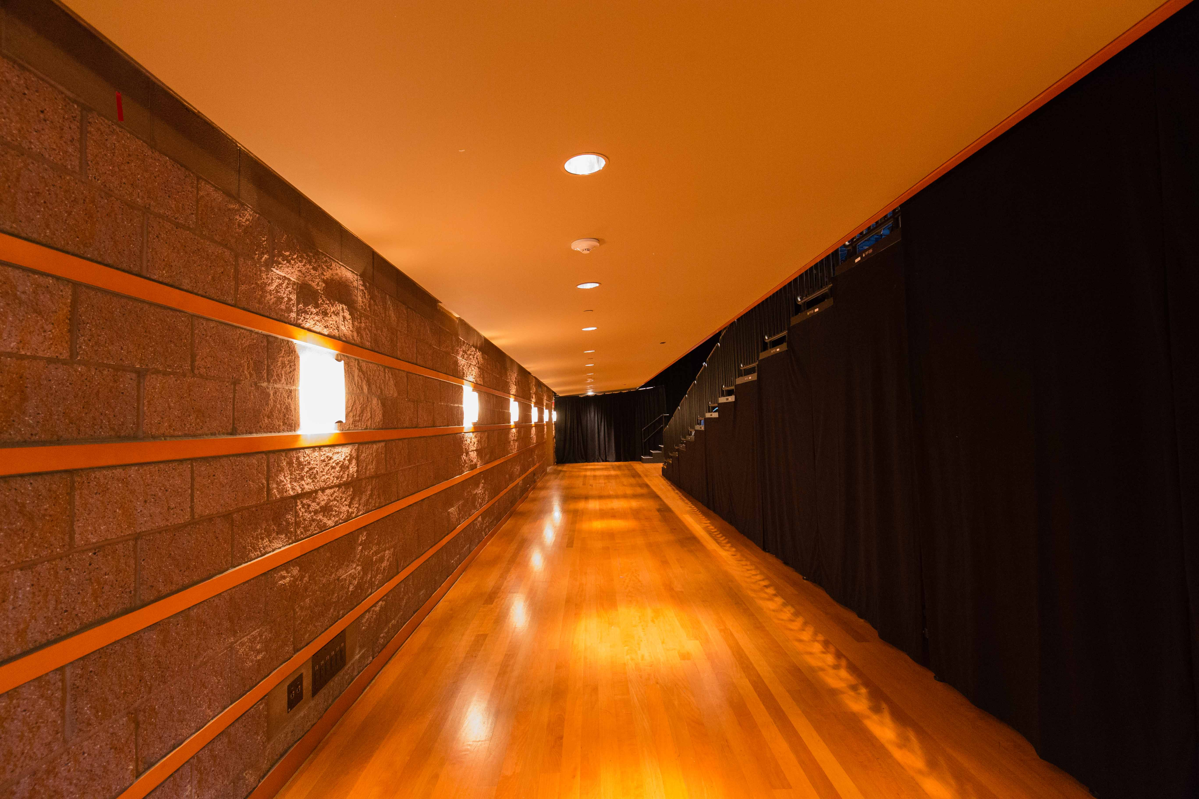
When we enter the theater, there will be black curtains on the left or right side of us.

My seat

Every seat in the theater has a letter and number on the seat.
Every ticket has a letter and a number.
I will match the ticket letter and number with the seat letter and number.

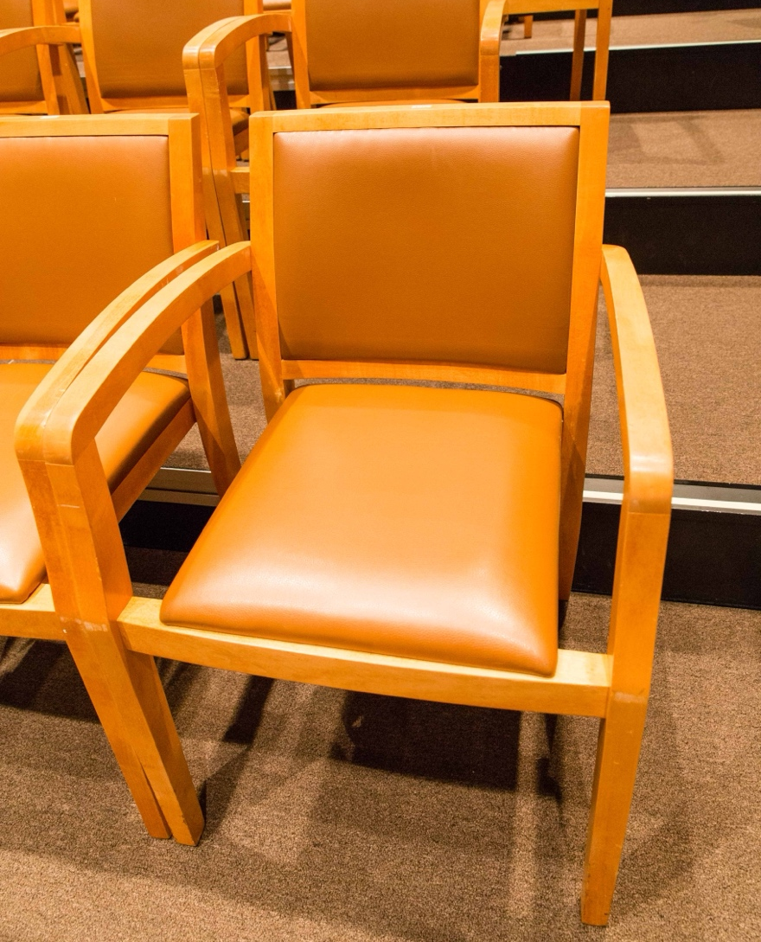
An usher will help me find my seat. This is where I will sit for the show.

Stairs

I will be careful when I walk up/down the stairs to get to my seat.
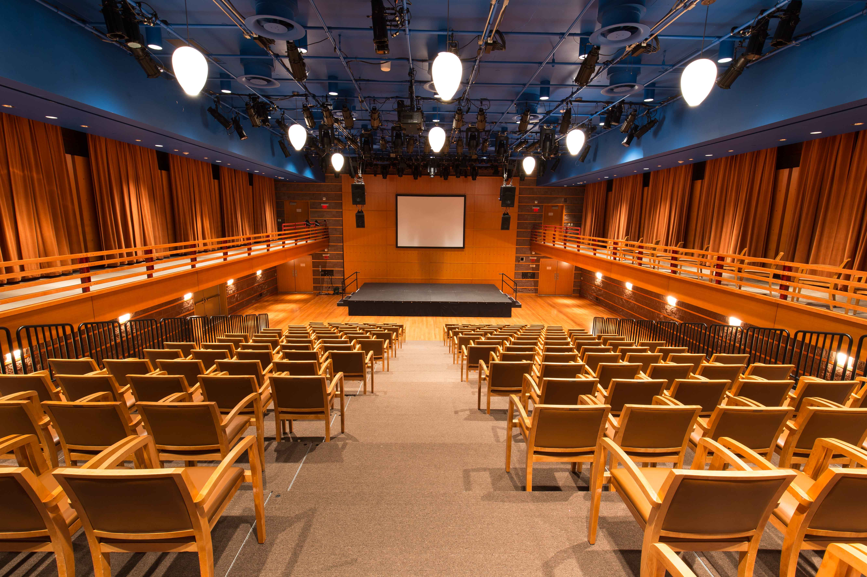
I can hold onto the railing when I walk down the stairs.

Sitting

I will always be sitting next to my family.

I might have my family on one side of me and a person I don’t know on the other side of me.

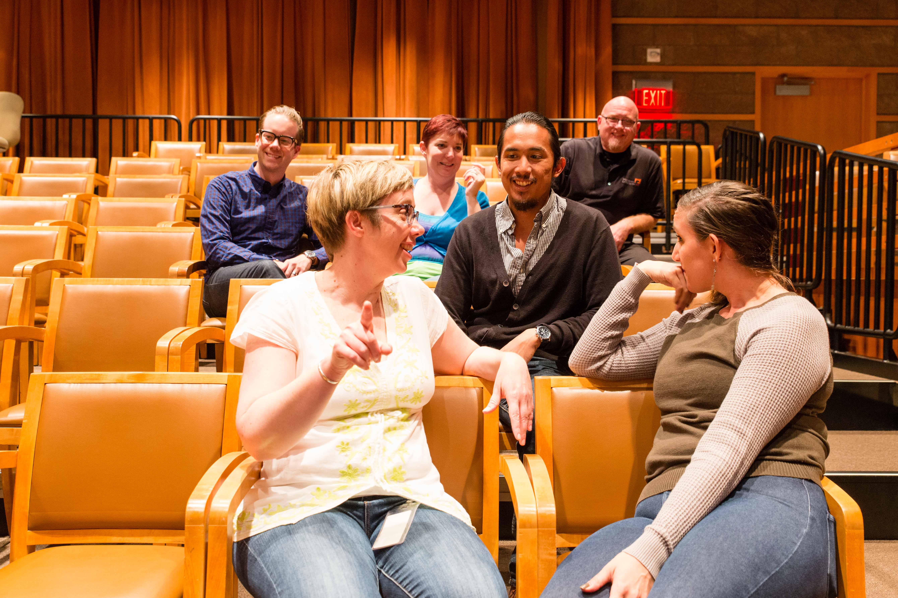
When I am sitting, sometimes a person will walk in front of me.

Bathroom

I will let my family know if I have to go to the bathroom.
I can go to the bathroom any time I need.
The toilet will flush when I stand up.

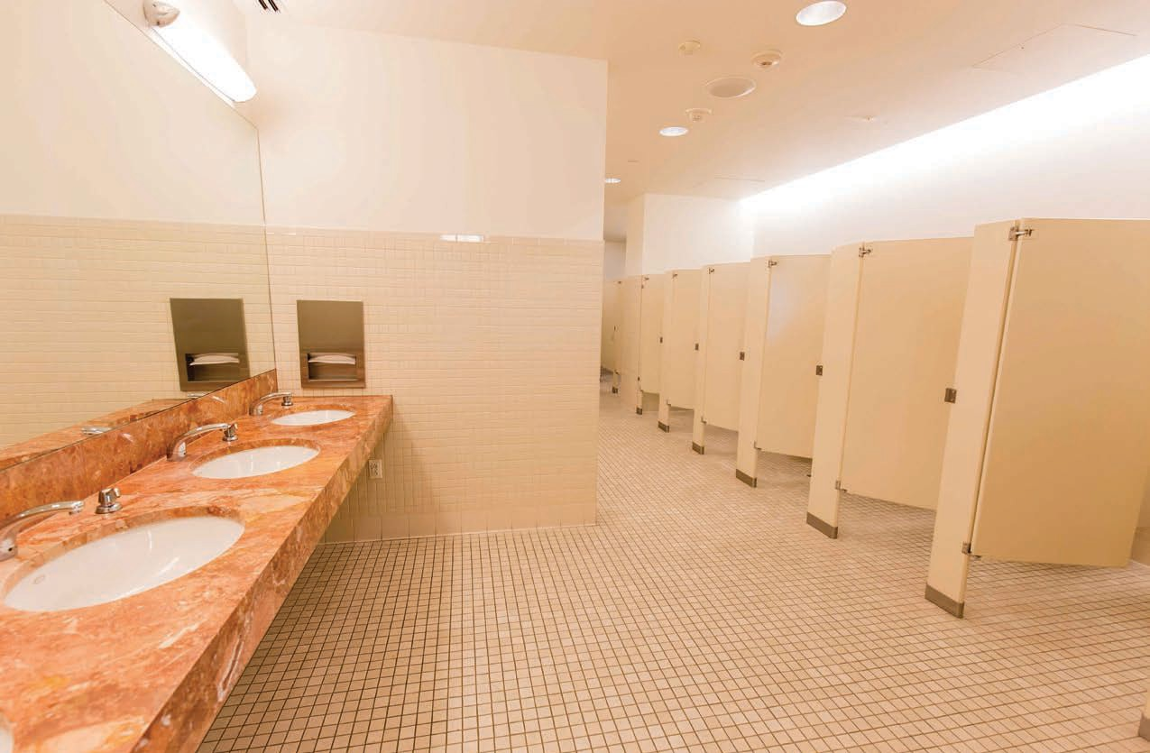The sound of the flushing toilet can be loud and flush more than one time.

Quiet lobby

I will tell my family if I want some quiet time.
I can leave the show and go to the quiet lobby.
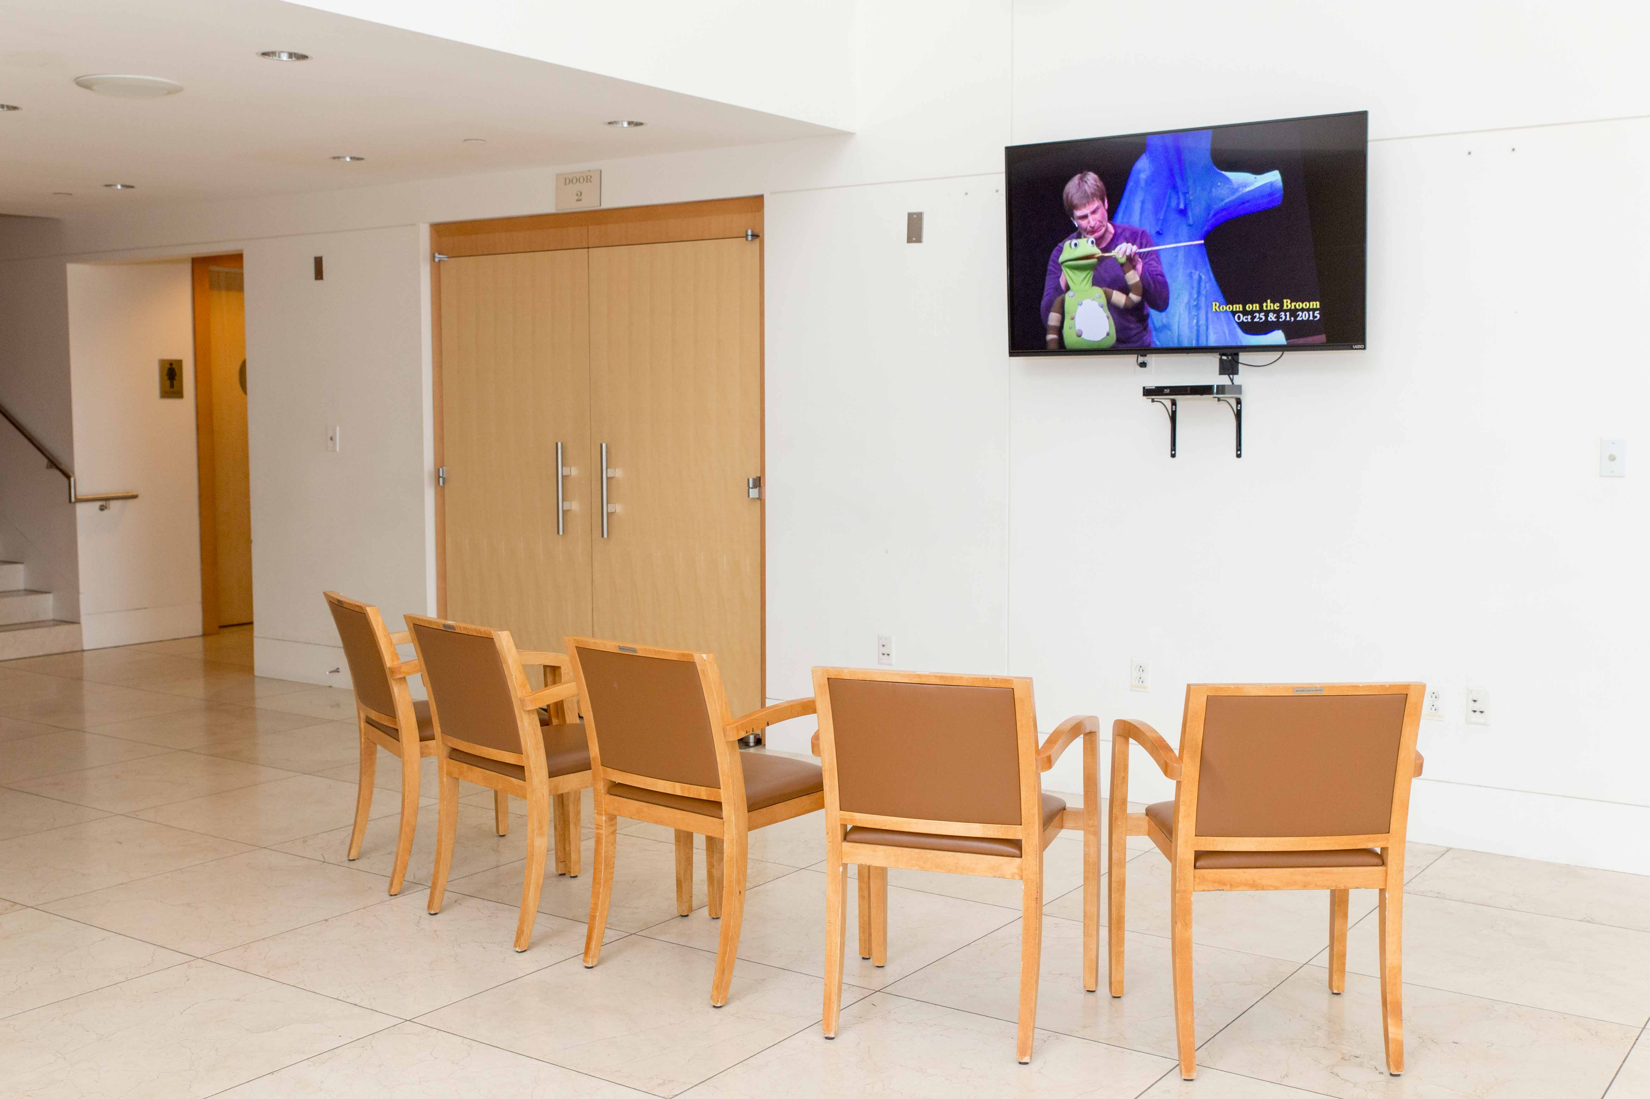
I can sit in a chair or walk around the lobby.

TV monitor

If I need a break from the show, I can go to the lobby.
The lobby will have a TV monitor.
I can still watch the show on the TV in the lobby.

Break Space

If I need a break from the show, I can go to the break space.
The break space will have pillows and cushions to relax on.
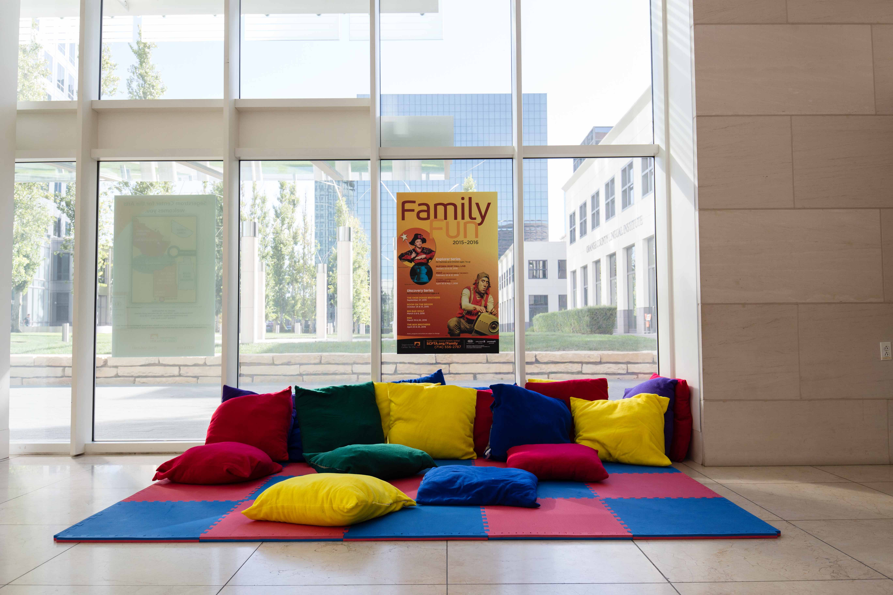
I can still watch the show on the TV monitor from the break space.

Clapping

The show ends when the actors bow.

If I like the show, I can clap when the show ends.
Other people will clap.
I can cover my ears if the clapping noise is too loud.

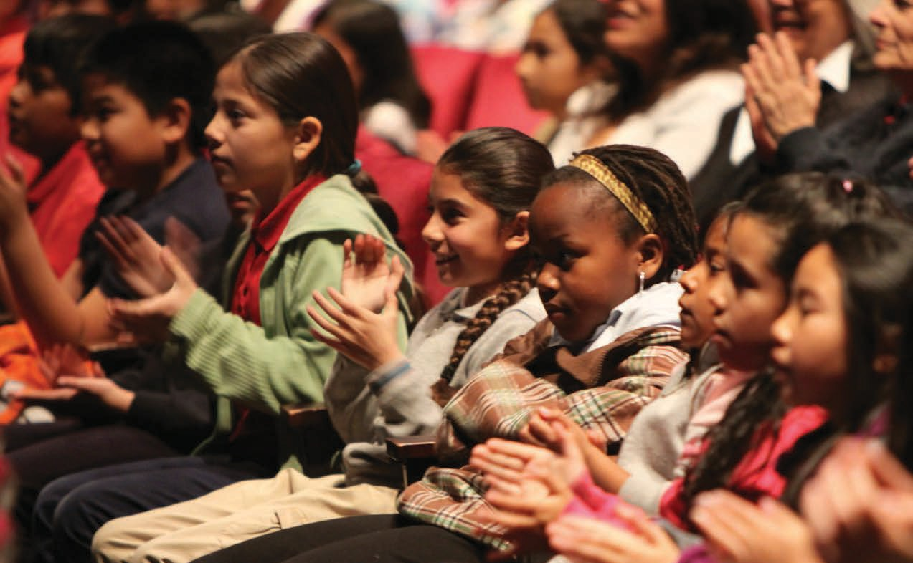People clap only for a short time, then the clapping is over.

Leaving

I have to walk up or down the stairs to leave the theater.
All the people will leave the theater at the same time.
The stairs will be crowded.
I will walk slowly on the stairs.
